IBM – Nutrition Assistant Application

SETTING UP THE APPLICATION ENVIRONMENT

|  |  |
| --- | --- |
| Date | 12 November 2022 |
| Team ID | PNT2022TMID12518 |
| Project Name | Project – Nutrition Assistant Application |
| Maximum Marks | 8 Marks |

TEAM MEMBERS : KANISKA VARSINI P D (TEAM LEADER) - 19Z222

DEEPIKA S (TEAM MEMBER 1) - 19Z209

G SOLAI SNEHA (TEAM MEMBER 2) - 19Z212

PRANITHA V S (TEAM MEMBER 3) - 19Z233

1**)CREATE CLOUD IBM ACCOUNT**

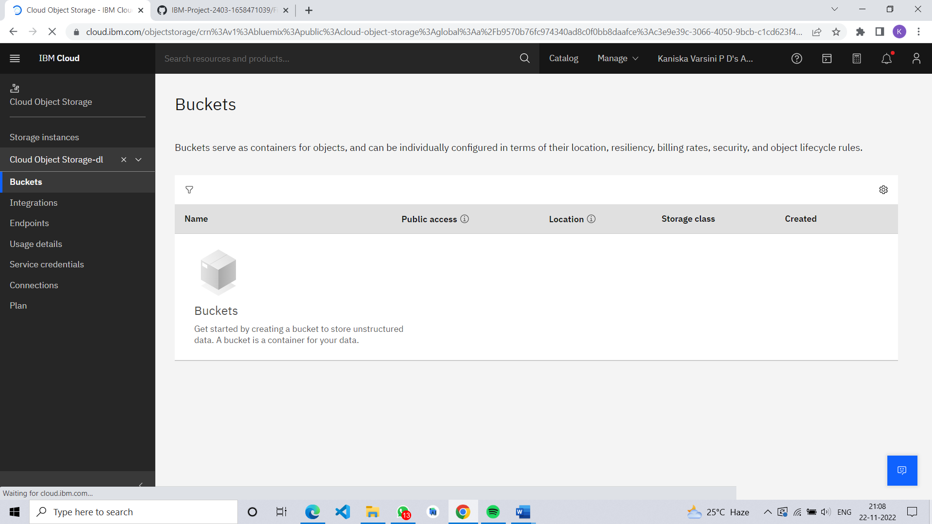

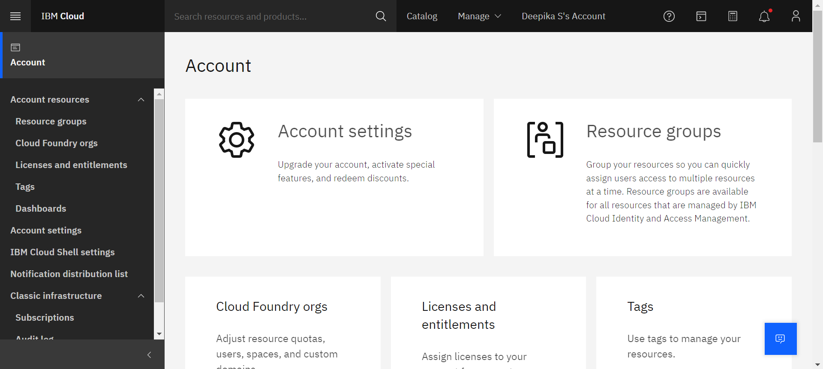

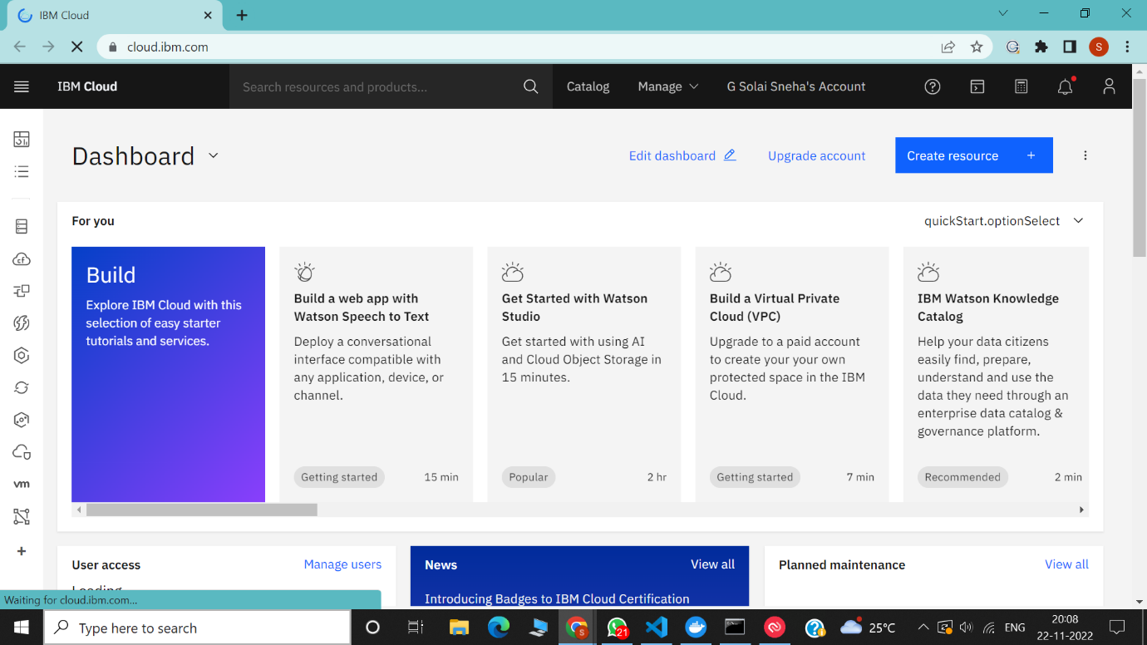

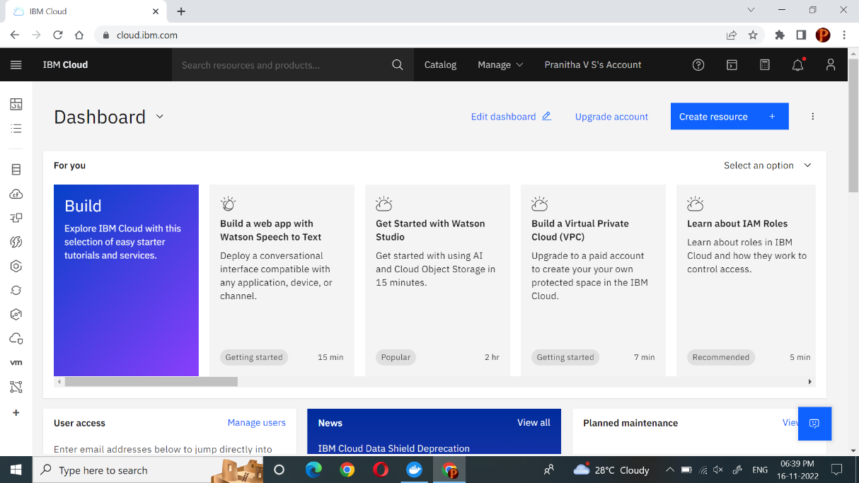

2) CREATE FLASK PROJECT

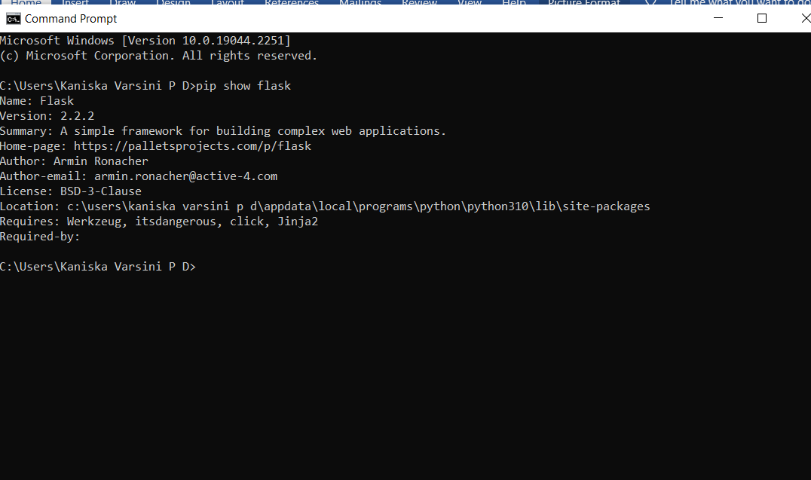

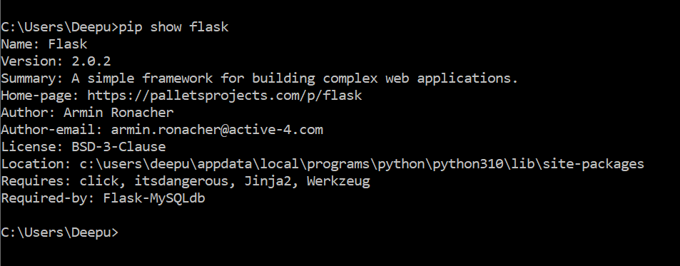

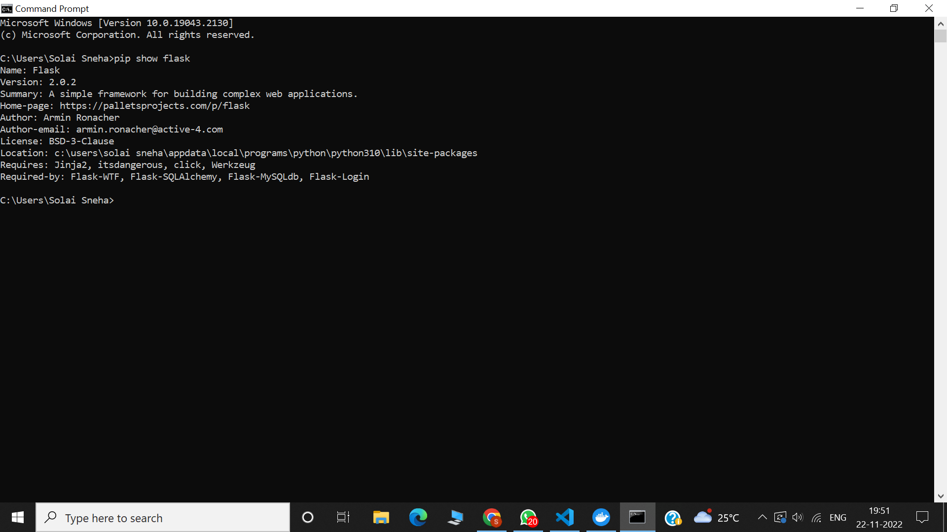

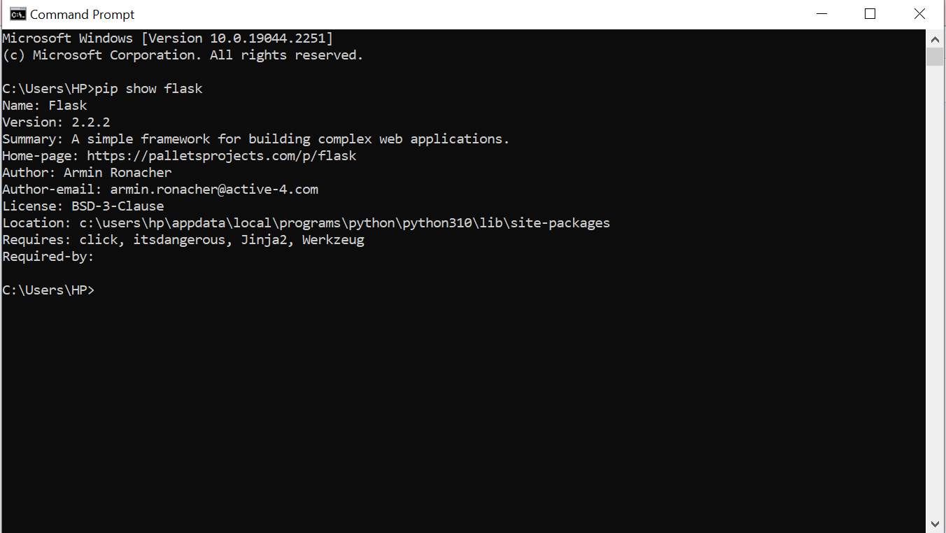

3) INSTALL IBM CLOUD CLI

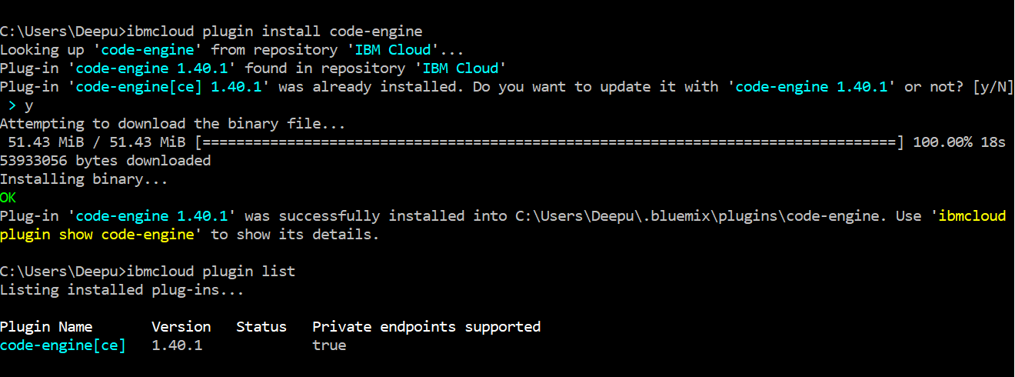

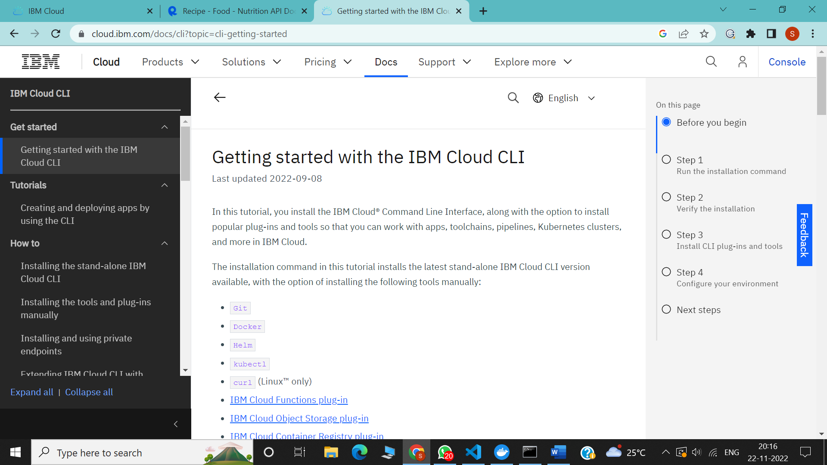

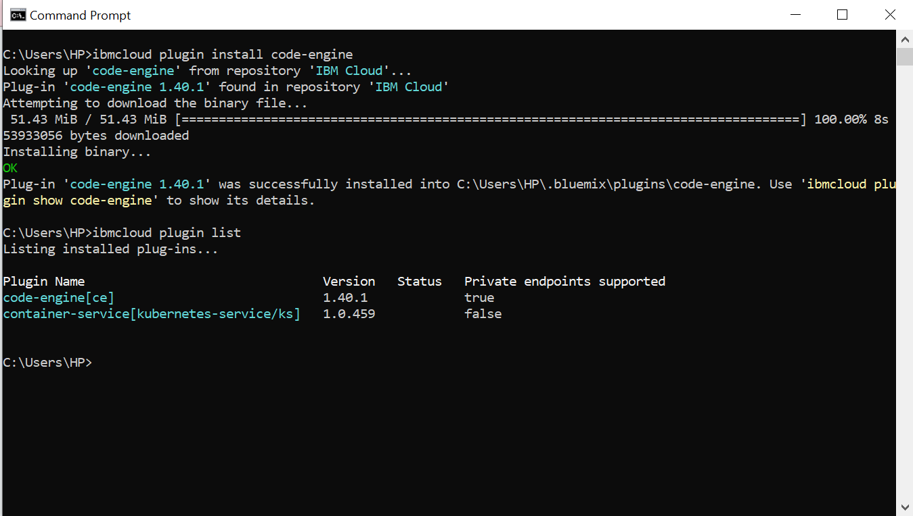

4) DOCKER CLI INSTALLATION

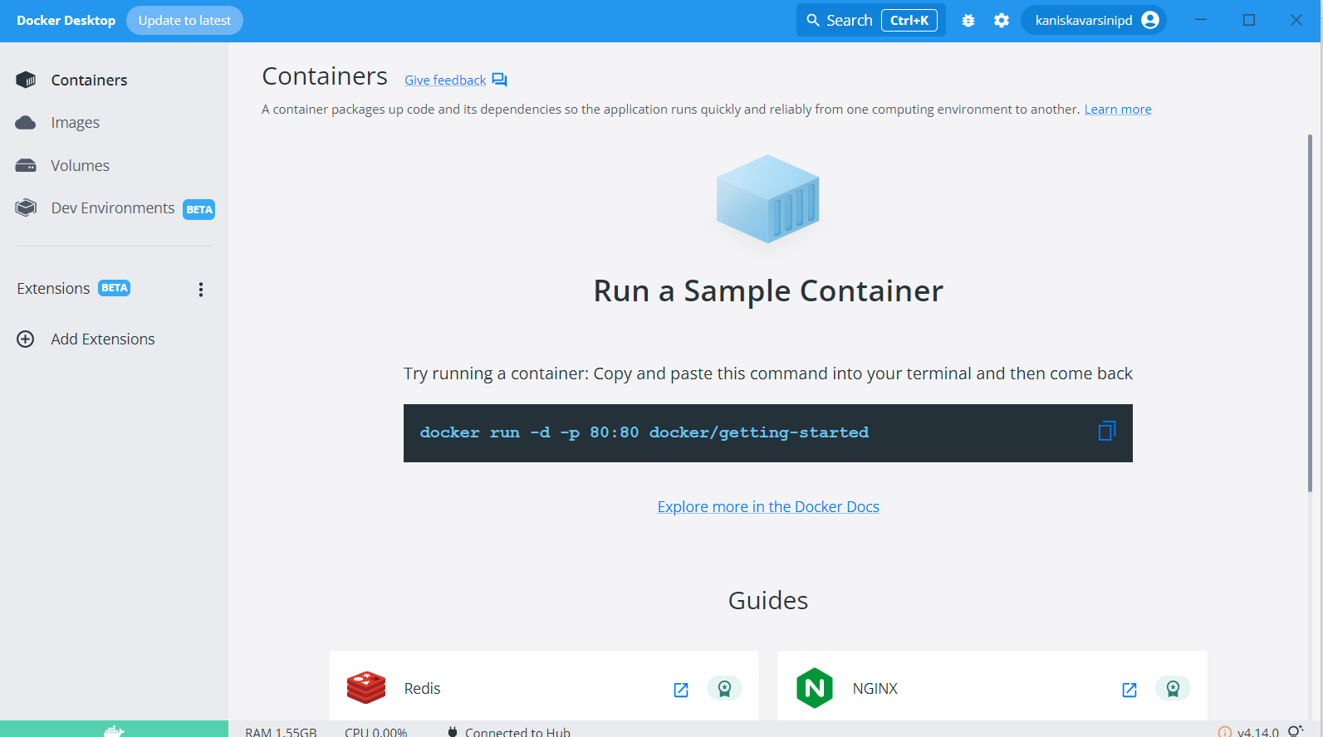

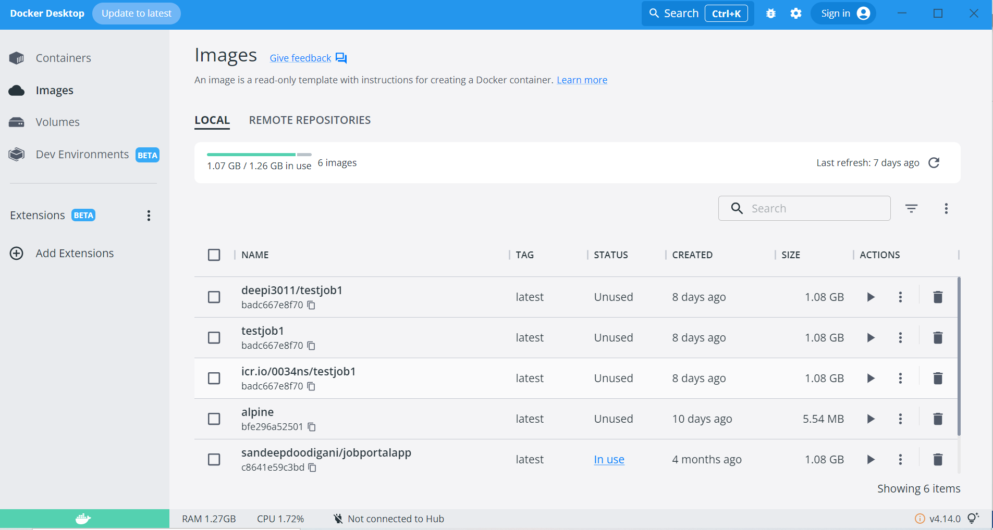

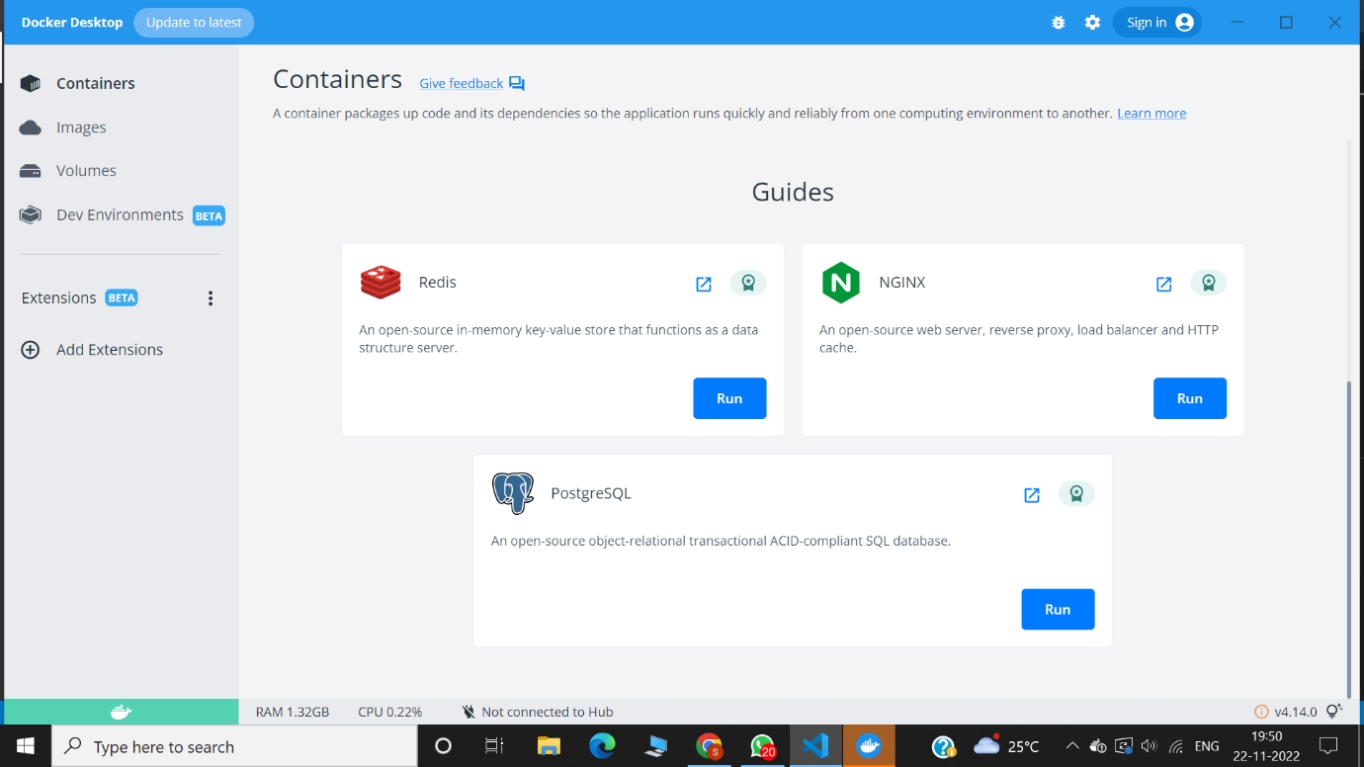

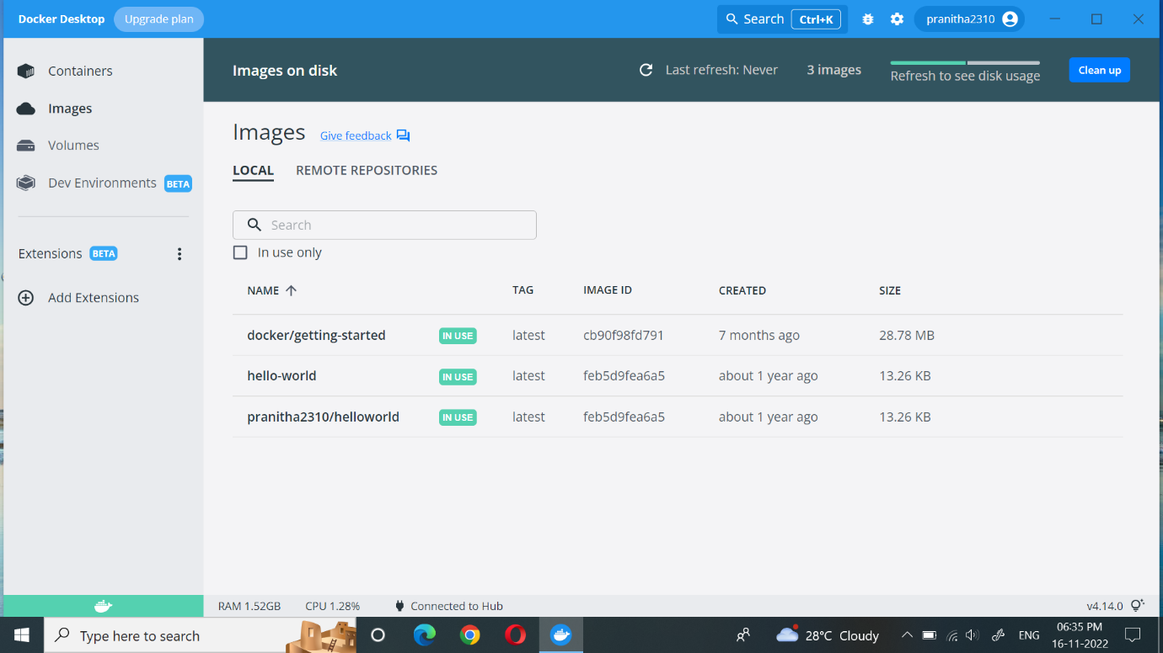

5)CREATE AN ACCOUNT IN NUTRITION API

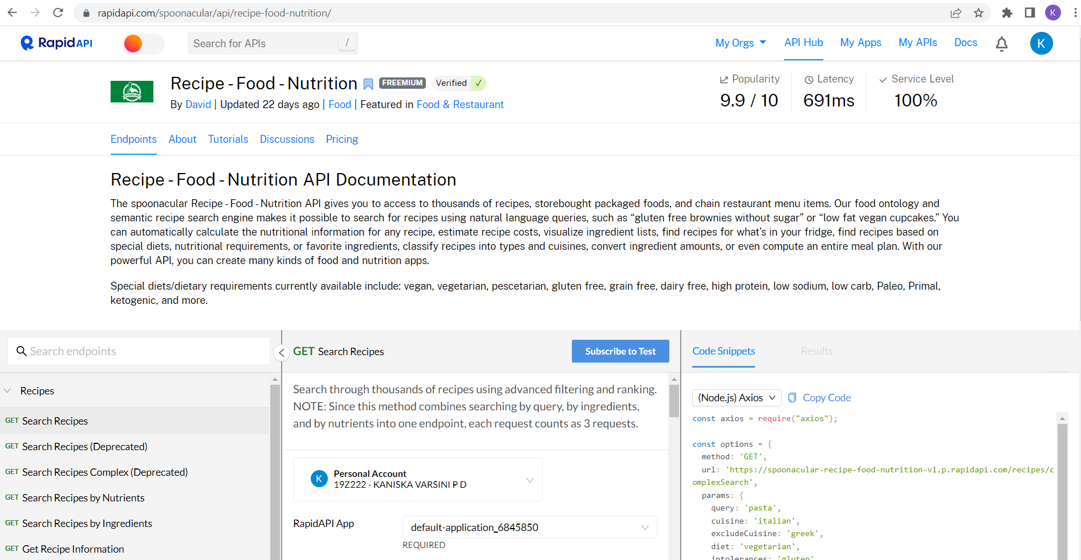

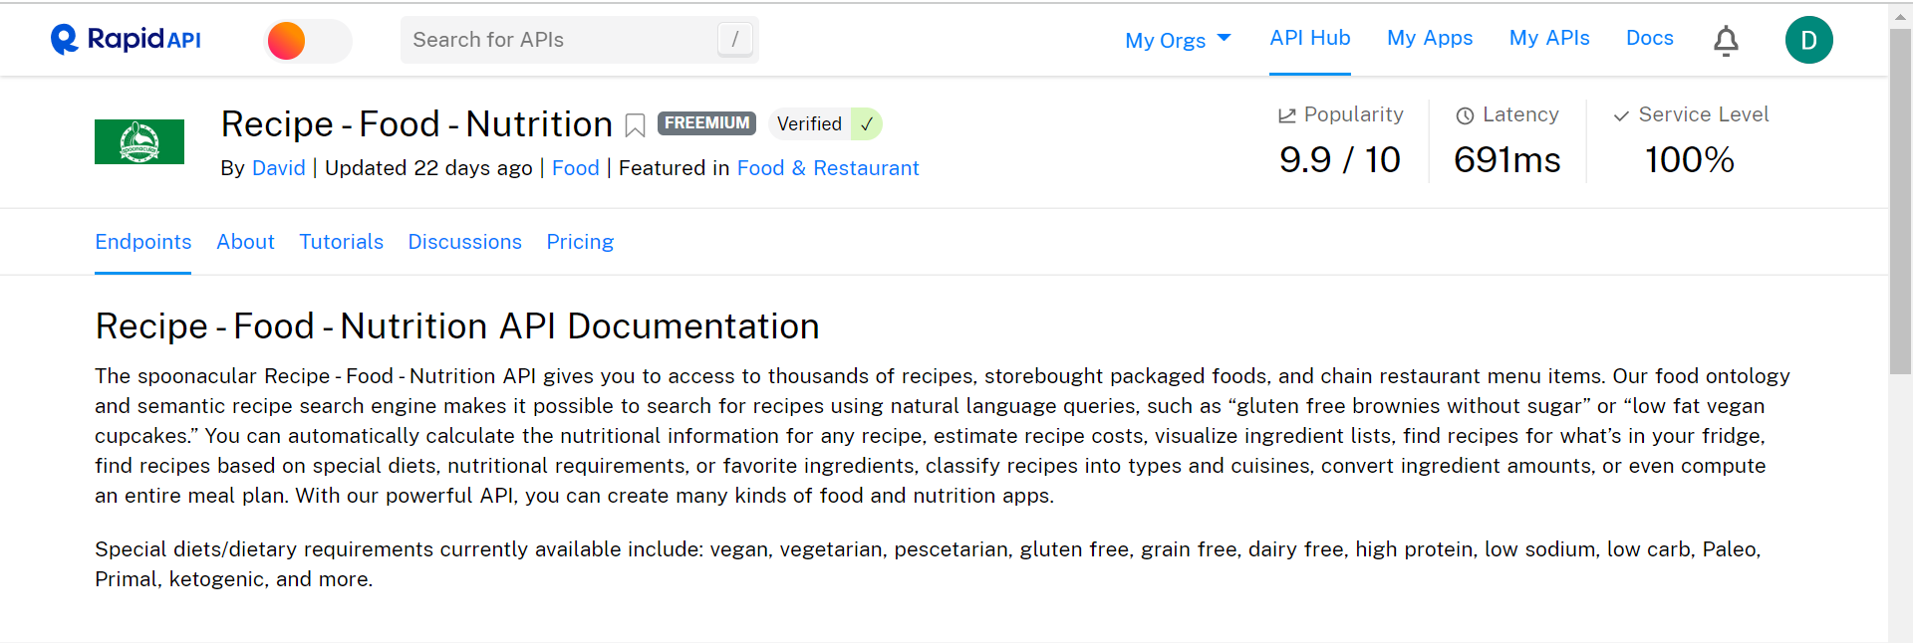

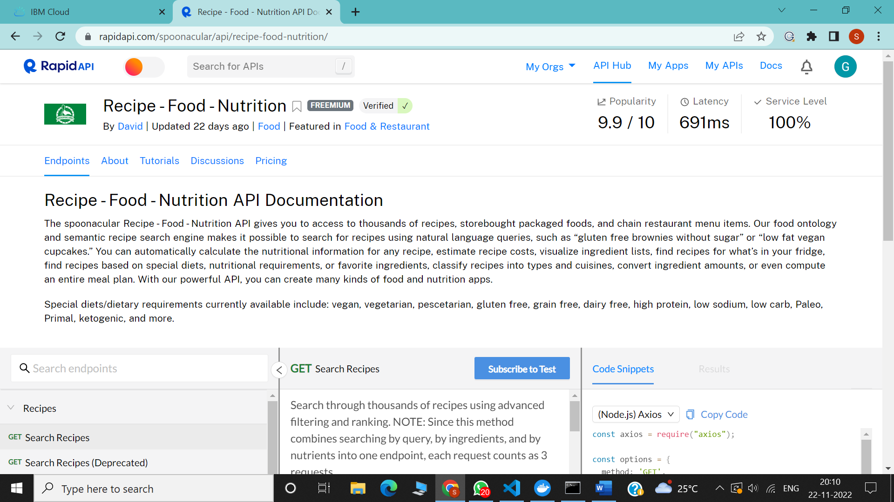

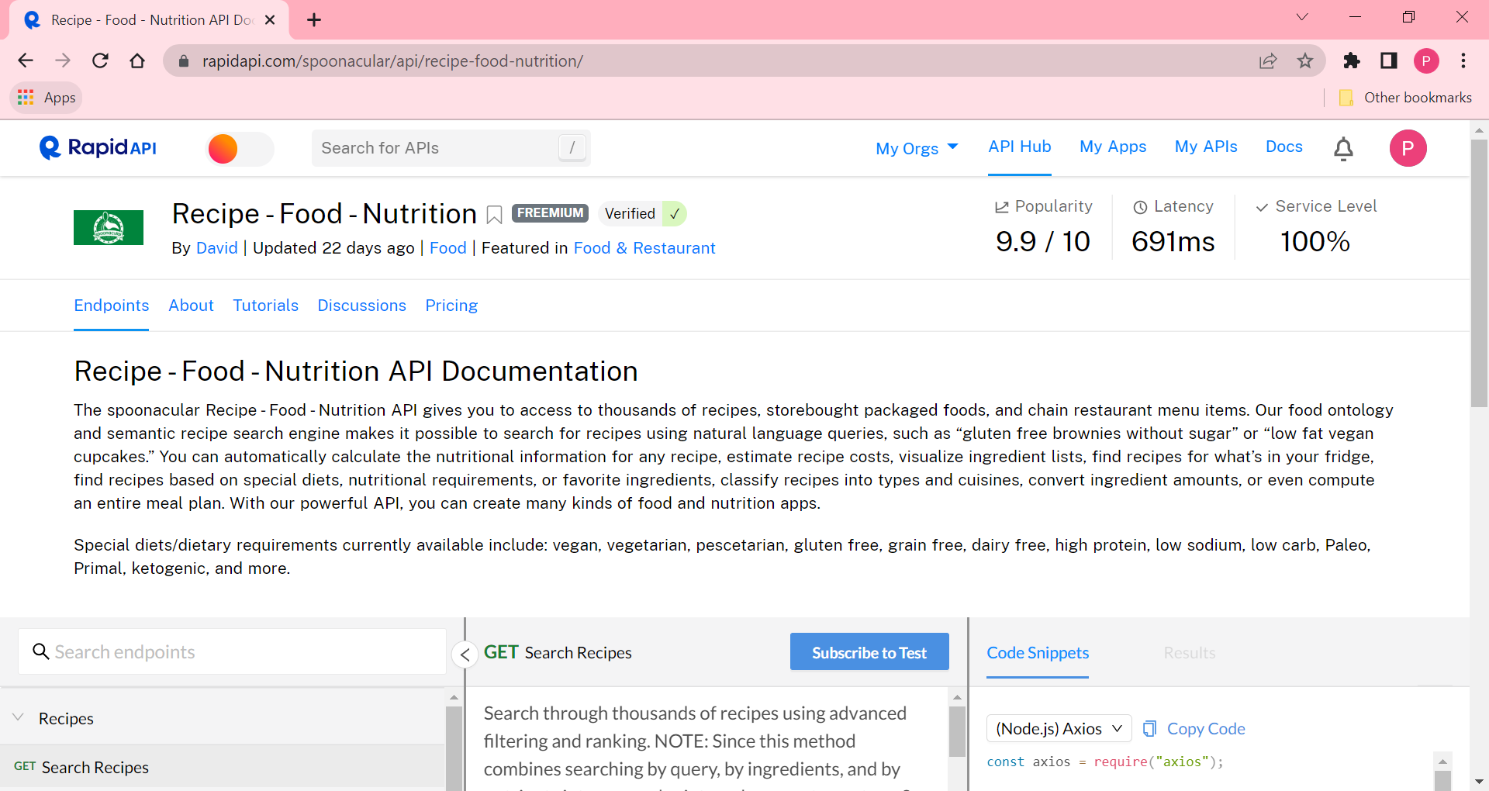

6)CREATE AN ACCOUNT IN SENDGRID

